*Florida International University*

*School of Computing and Information Sciences*

Software Engineering Focus

Feature Document

User Story ID 676

**Name:** Account Settings

**Team Member(s):** Leandro Gonzalez,Luis Herrnsdorf

**Project:** Smart Stormwater (Smart City System) 2.0

**Product Owner(s)**: Emilio Lopez

**Mentor(s)**:

**Instructor**: Masoud Sadjadi

**User Story Name:** Account Settings

* Description: As a User I want to be able to change my profile information so that I can edit my phone number, password, and name.

Acceptance Criteria

* Once logged in, the user may go to the account settings page to find their information displayed appropriately (ex. the phone number is displayed in the phone field, email is displayed in the email field, etc.)
* After editing the information, the user clicks the “Update Profile” button and the system updates any information that is changed to the database
* If there are any erroneous edits, there should be a notice nearby the field indicating the error
* Users can click on the “Change Password” button to change their password
* In order to change password, users must enter their current password, and provide the new password twice

**Use Case**

* Name: Update Profile Info
* Actor: User, System
* Preconditions: User is logged in
* Description: User clicks on ‘Profile’ dropdown on top right corner. User clicks on ‘Account’ option from the dropdown. User is redirected to a page containing the user’s information. User can see his/her role, department, email. User can edit his/her first name, last name, and phone number, and click on ‘Update Profile’ to save the changes. User can click on ‘Change Password’ button to change his/her password. User must provide current password, and the new password (twice). The current password must be correct, and the new password must match.

**Use Case Diagram**

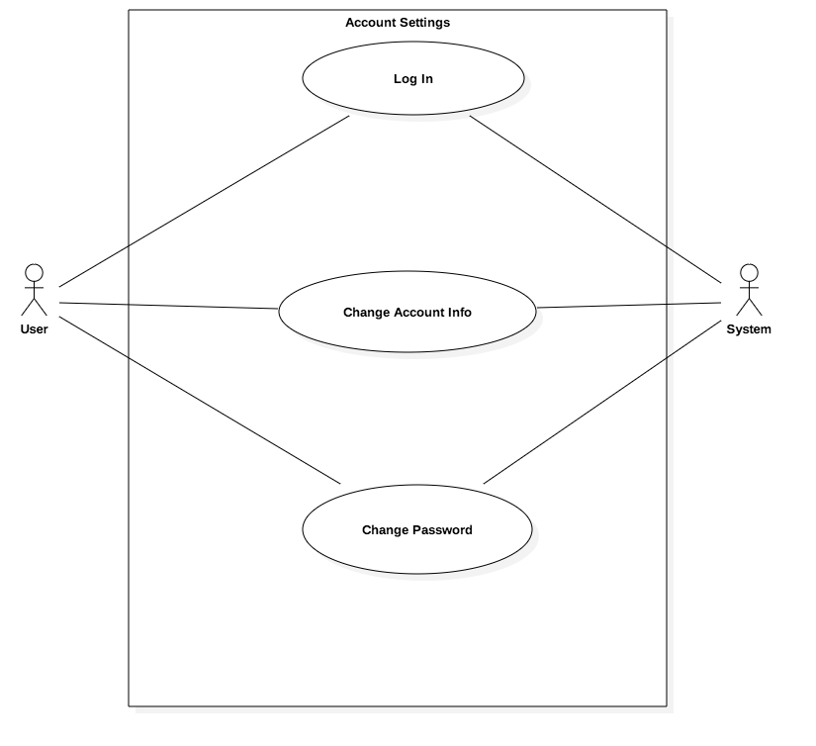

**Sequence Diagram**

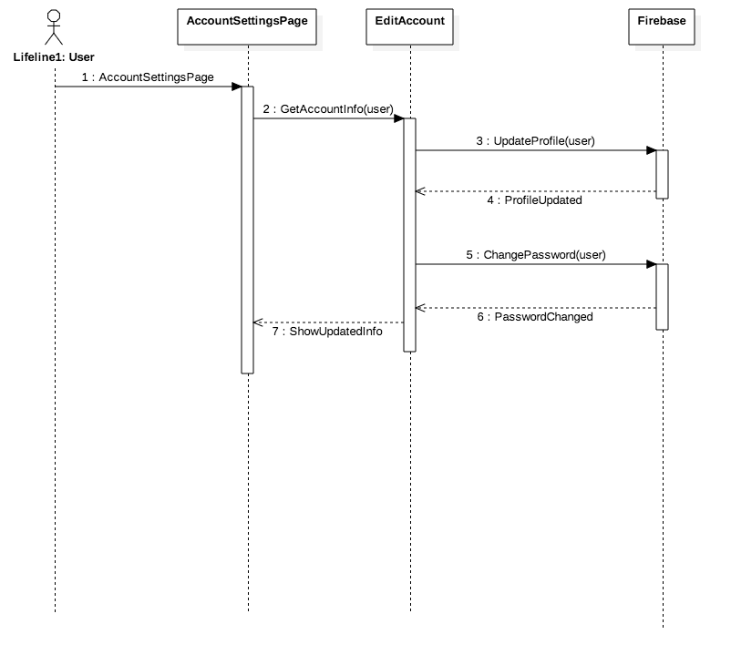

**Class Diagram**

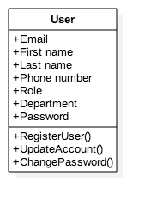

**Unit Test**

* Test case ID: AccountSettings001
* Description/Summary of Test: User updates his/her account information (first name, last name, phone number), and changes his/her password
* Pre-condition: User is logged in; first and last names are provided (these two fields are mandatory)
* Expected Results: The changes will be persisted
* Actual Result: User was able to change his/her first name, last name, phone number, and password
* Status (Fail/Pass): Pass

**Visual User Guide**

